COURSE CERTIFICATE

This is to certify that

**DHYAN SANTHOSH K**

has successfully completed the course by demonstrating

theoretical and practical understanding of

Introduction to C



Certificate CC-JSSXEOII

Issued 19 December, 2024

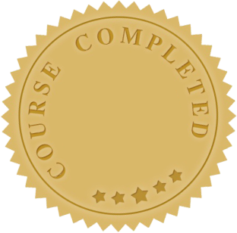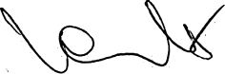

**Yeva Hyusyan**

Chief Executive Officer